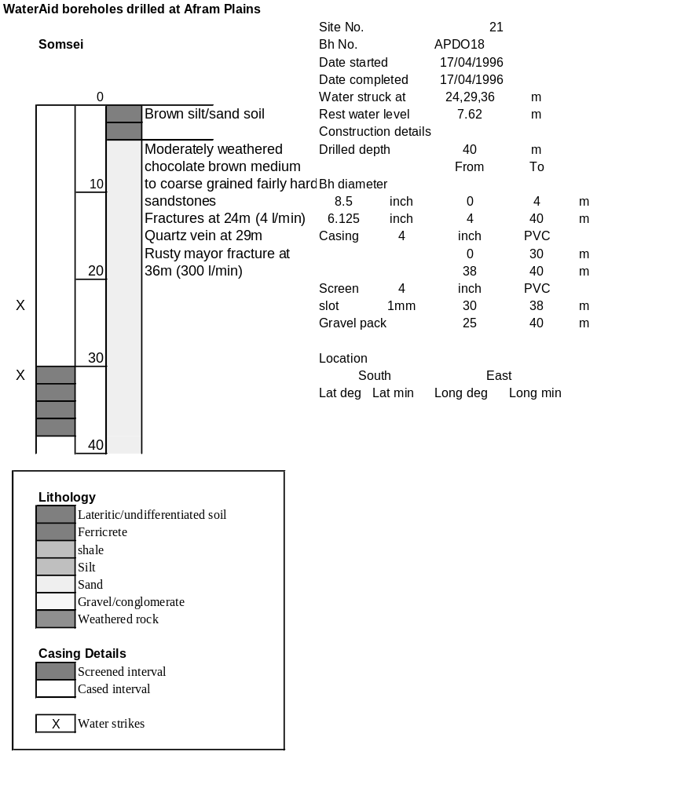

Ghana | Test pumping
Borehole No. |  | APDO18
Hole No |  | 21
Village |  | Somei
Date |  | 22/04/1996
Point above GL |  | 0.5 | m
Pump depth |  | 29 | m
SWL |  | 8.12 | m
Start Time |  | 14:25
Drawdown test |  |  |  |  | Recovery test
time | pwl (m) | Q l/min | dd | sc | Time | wl (m) | s' | t/t'
0.00 | 8.12 | 150.00 | 0.00 |  | 0.00 | 22.29 | 14.17
1.00 | 9.70 | 150.00 | 1.58 | 94.94 | 1.00 | 20.75 | 12.63 | 181.00
2.00 | 10.12 | 150.00 | 2.00 | 75.00 | 2.00 | 20.29 | 12.17 | 91.00
3.00 | 10.47 | 150.00 | 2.35 | 63.83 | 3.00 | 19.91 | 11.79 | 61.00
4.00 | 10.82 | 150.00 | 2.70 | 55.56 | 4.00 | 19.59 | 11.47 | 46.00
5.00 | 11.11 | 150.00 | 2.99 | 50.17 | 5.00 | 19.32 | 11.20 | 37.00
6.00 | 11.35 | 150.00 | 3.23 | 46.44 | 6.00 | 19.02 | 10.90 | 31.00
7.00 | 11.58 | 150.00 | 3.46 | 43.35 | 7.00 | 18.87 | 10.75 | 26.71
8.00 | 11.80 | 150.00 | 3.68 | 40.76 | 8.00 | 18.67 | 10.55 | 23.50
9.00 | 12.00 | 150.00 | 3.88 | 38.66 | 9.00 | 18.49 | 10.37 | 21.00
10.00 | 12.20 | 150.00 | 4.08 | 36.76 | 10.00 | 18.32 | 10.20 | 19.00
11.00 | 12.39 | 150.00 | 4.27 | 35.13 | 12.00 | 18.00 | 9.88 | 16.00
12.00 | 12.55 | 150.00 | 4.43 | 33.86 | 14.00 | 17.72 | 9.60 | 13.86
13.00 | 12.72 | 150.00 | 4.60 | 32.61 | 16.00 | 17.45 | 9.33 | 12.25
14.00 | 12.87 | 150.00 | 4.75 | 31.58 | 18.00 | 17.20 | 9.08 | 11.00
15.00 | 13.03 | 150.00 | 4.91 | 30.55 | 20.00 | 16.97 | 8.85 | 10.00
16.00 | 13.18 | 150.00 | 5.06 | 29.64 | 22.00 | 16.74 | 8.62 | 9.18
17.00 | 13.33 | 150.00 | 5.21 | 28.79 | 24.00 | 16.53 | 8.41 | 8.50
18.00 | 13.47 | 150.00 | 5.35 | 28.04 | 26.00 | 16.33 | 8.21 | 7.92
19.00 | 13.59 | 150.00 | 5.47 | 27.42 | 28.00 | 16.11 | 7.99 | 7.43
20.00 | 13.71 | 150.00 | 5.59 | 26.83 | 30.00 | 15.94 | 7.82 | 7.00
22.00 | 13.97 | 150.00 | 5.85 | 25.64 | 35.00 | 15.50 | 7.38 | 6.14
24.00 | 14.22 | 150.00 | 6.10 | 24.59 | 40.00 | 15.13 | 7.01 | 5.50
26.00 | 14.43 | 150.00 | 6.31 | 23.77 | 45.00 | 14.75 | 6.63 | 5.00
28.00 | 14.66 | 150.00 | 6.54 | 22.94 | 50.00 | 14.42 | 6.30 | 4.60
30.00 | 14.88 | 150.00 | 6.76 | 22.19 | 60.00 | 13.85 | 5.73 | 4.00
35.00 | 15.37 | 150.00 | 7.25 | 20.69 | 70.00 | 13.36 | 5.24 | 3.57
40.00 | 15.82 | 150.00 | 7.70 | 19.48 | 80.00 | 12.95 | 4.83 | 3.25
45.00 | 16.26 | 150.00 | 8.14 | 18.43 | 90.00 | 12.60 | 4.48 | 3.00
50.00 | 16.65 | 150.00 | 8.53 | 17.58 | 100.00 | 12.30 | 4.18 | 2.80
55.00 | 17.50 | 150.00 | 9.38 | 15.99 | 110.00 | 12.05 | 3.93 | 2.64
60.00 | 17.41 | 150.00 | 9.29 | 16.15 | 120.00 | 11.89 | 3.77 | 2.50
70.00 | 18.10 | 150.00 | 9.98 | 15.03
80.00 | 18.73 | 150.00 | 10.61 | 14.14
90.00 | 19.24 | 150.00 | 11.12 | 13.49
100.00 | 19.74 | 150.00 | 11.62 | 12.91
110.00 | 20.18 | 150.00 | 12.06 | 12.44
120.00 | 20.59 | 150.00 | 12.47 | 12.03
130.00 | 20.95 | 150.00 | 12.83 | 11.69
140.00 | 21.29 | 150.00 | 13.17 | 11.39
160.00 | 21.83 | 150.00 | 13.71 | 10.94
180.00 | 22.29 | 150.00 | 14.17 | 10.59

